Univariate plots of Yaounde COVID study data

# 1 Administration of questionnaire

## 1.1 Is this the original sampled household?

(per household) 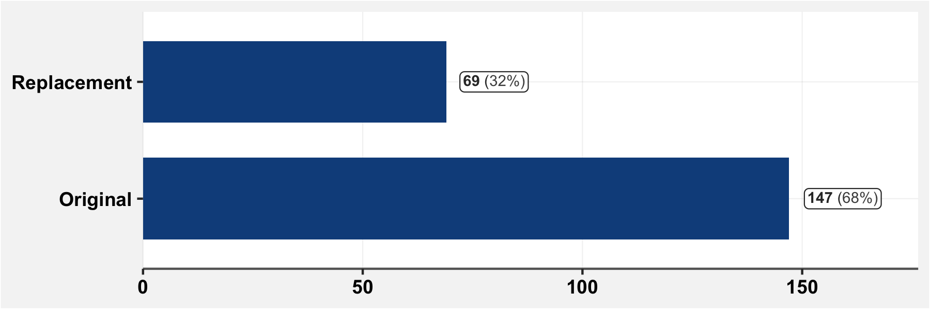

**NOTE** It is not clear to me whether 0 means “original” or “replacement”.

## 1.3 Which surveyors administered the questionnaire?

(per respondent) 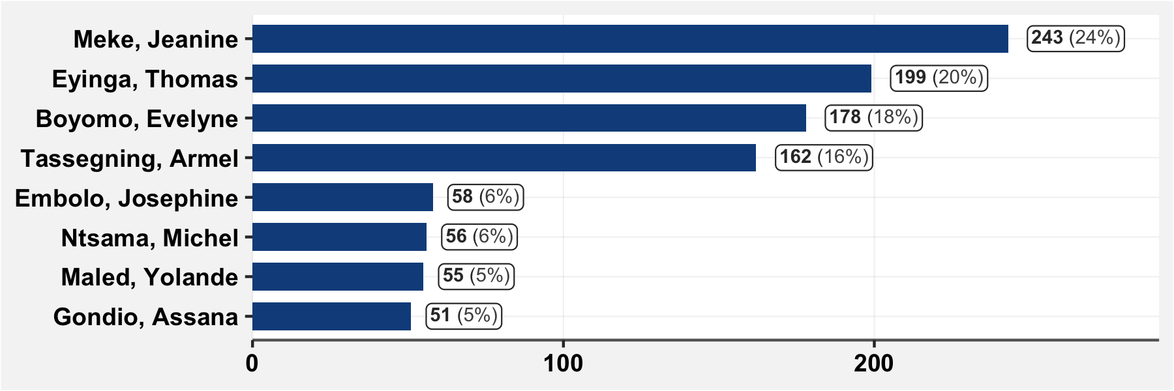

## 1.4 Date of survey completion

(per respondent) 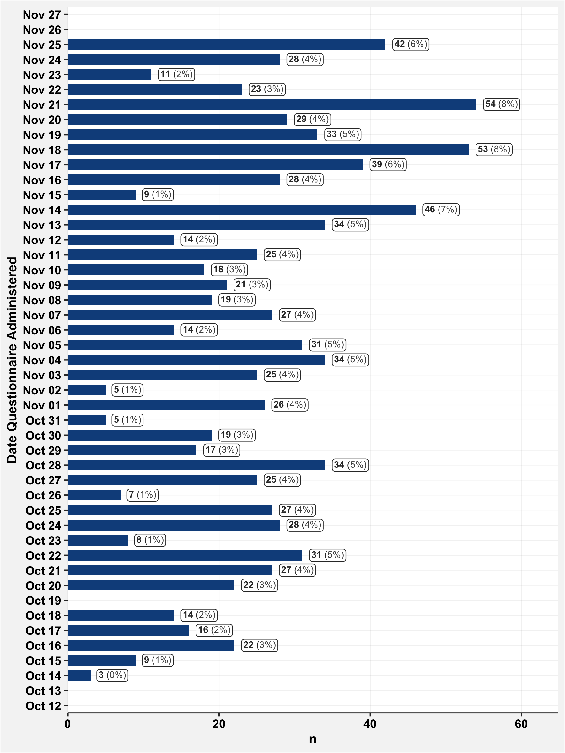

## 1.5 City Area

(per household) 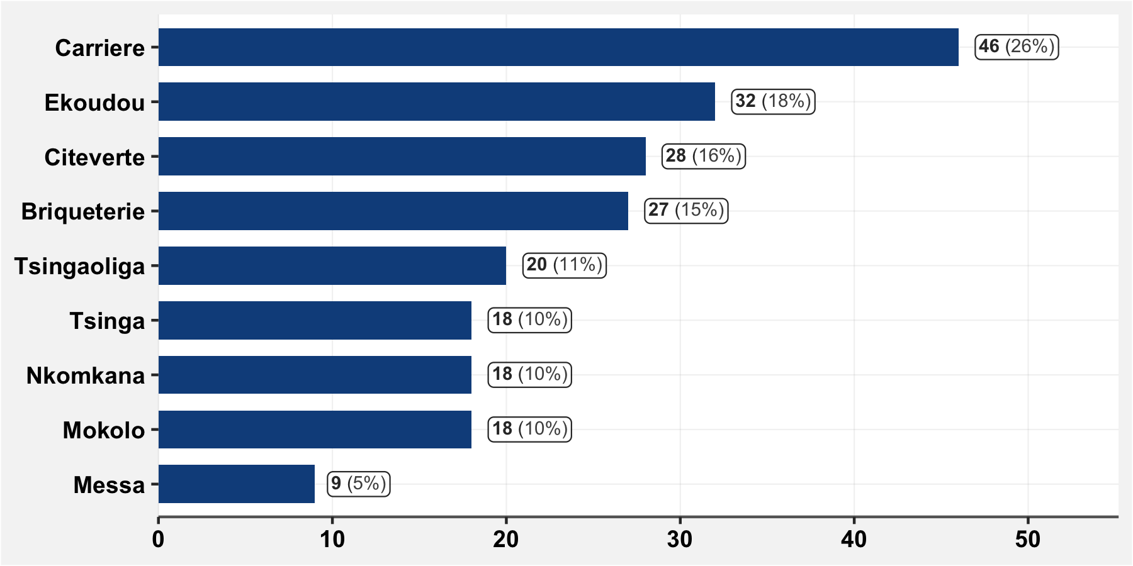

# 2 Household Composition

All variables below are per household. The answers from a single representative individual are taken to represent the information about the household.

This representative individual is either:

* The first “household head” to be interviewed in a household; or
* In cases where there is no head, the first individual above 18 to be interviewed in the household.

## 2.2 GPS location

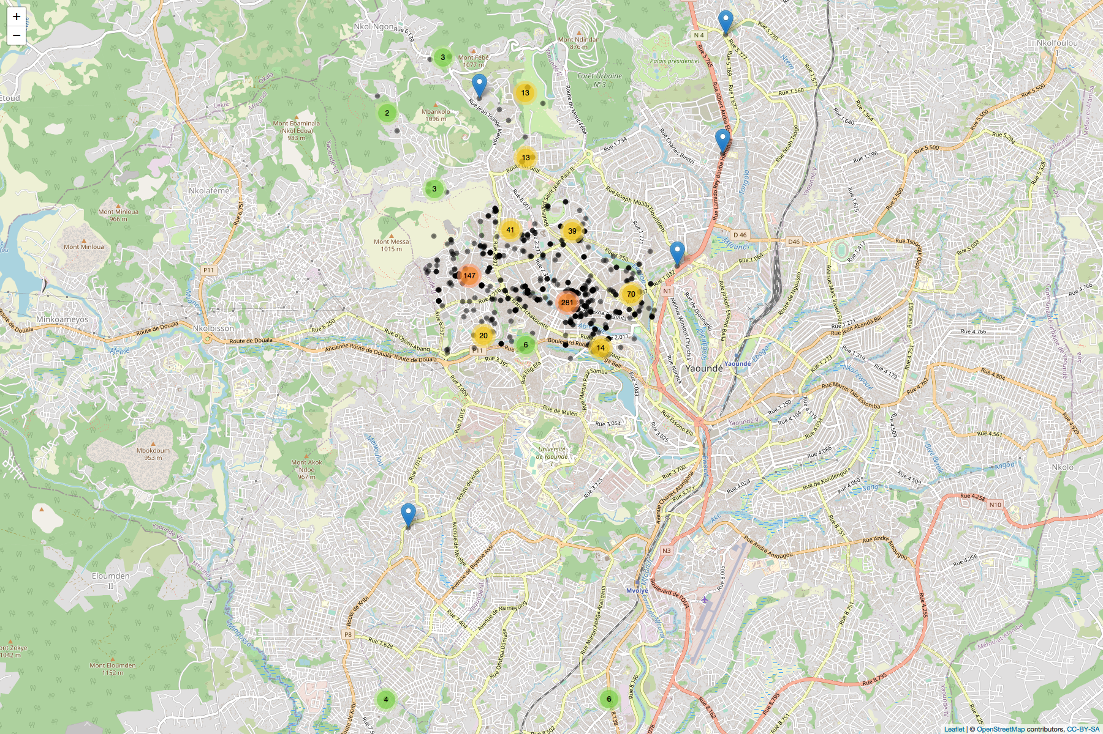

## 2.3 Number of rooms

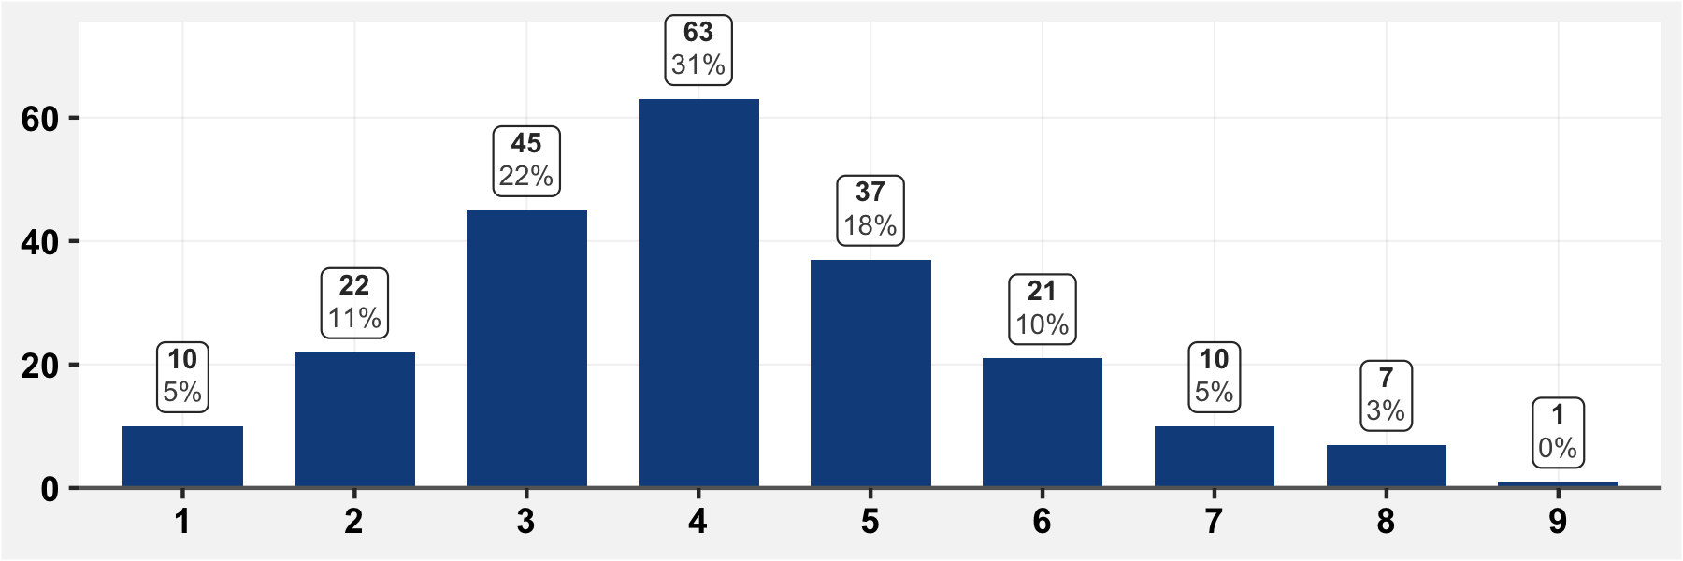

## 2.4 Number of adults

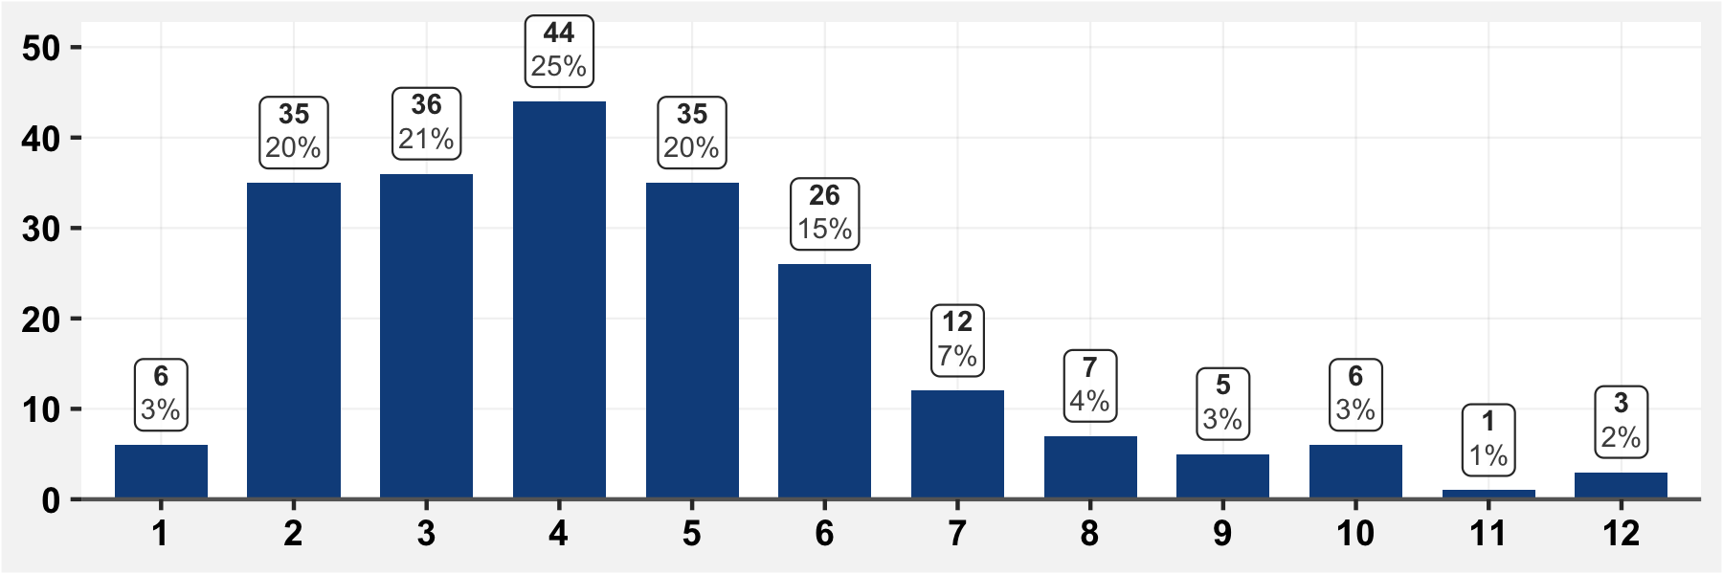

## 2.5 Number of children

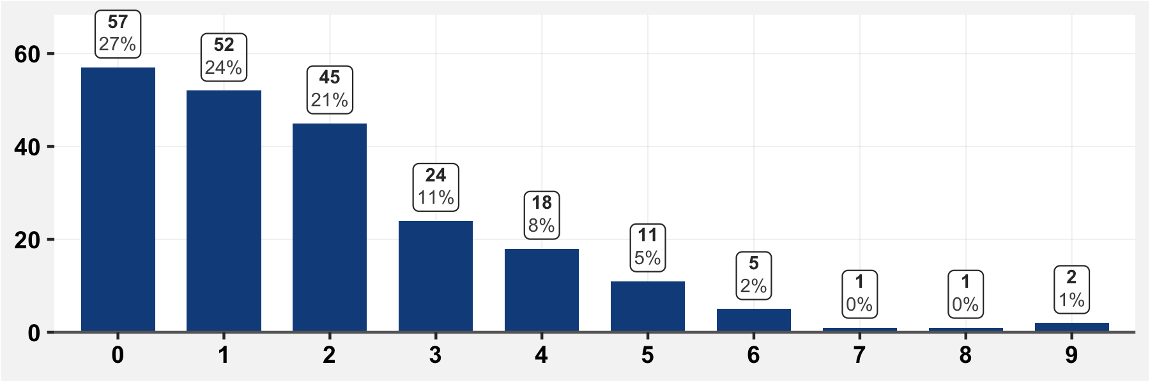

## 2.7 Have there been deaths in the household since March 1st?

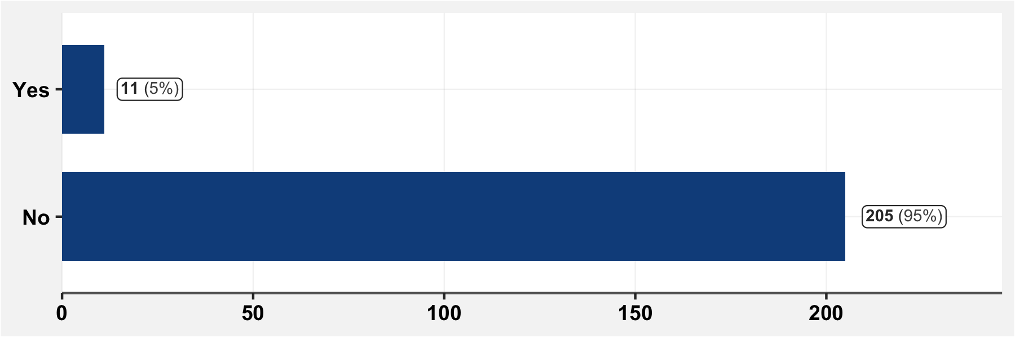

**NOTE** Here, NA means the cell was completely blank. NR means it was filled in as “Ne repond pas”

## 2.7.1 If there have been deaths in the household since March 1st, specify

All deaths reported are shown in the table below. No household had more than one death.

|  |  |  |  |
| --- | --- | --- | --- |
| **Date of Death** | **Sex** | **Age at Death** | **Cause of Death** |
| Oct 23 | M | 74 | Unspecified |
| Oct 22 | F | 44 | Unspecified |
| Oct 20 | F | 101 | Unspecified |
| Oct 11 | M | 83 | Unspecified |
| Aug 25 | F | 67 | Diabetes |
| Jun 25 | F | 63 | Unspecified |
| May 30 | M | 76 | Unspecified |
| May 07 | M | 73 | Unspecified |
| Apr 05 | M | 50 | Stroke |
| Unspecified | M | 50 | Cardiac arrest |
| Unspecified | M | 84 | Unspecified |

# 3 Information about the household

## 3.1 Are you the “Chef du menage”?

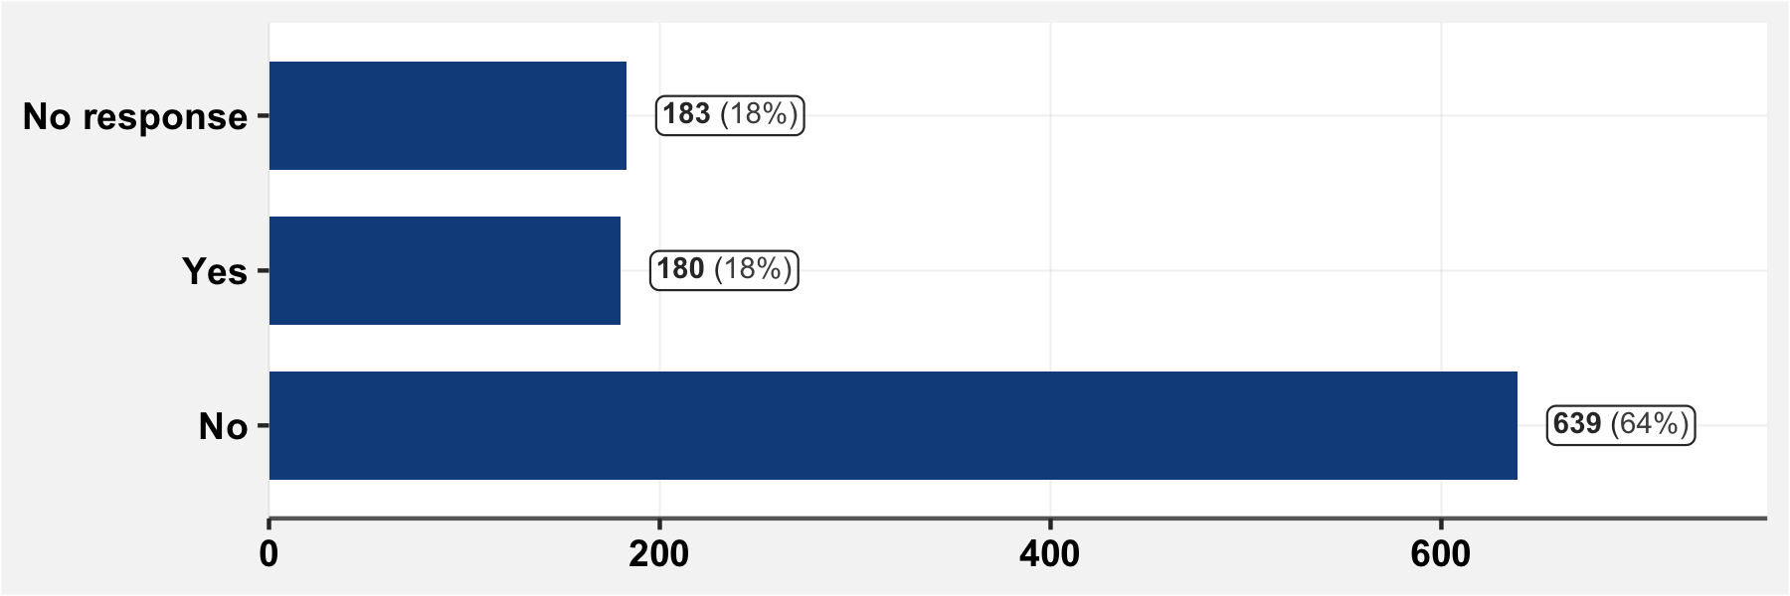

## 3.2 Are you the principal breadwinner in the household?

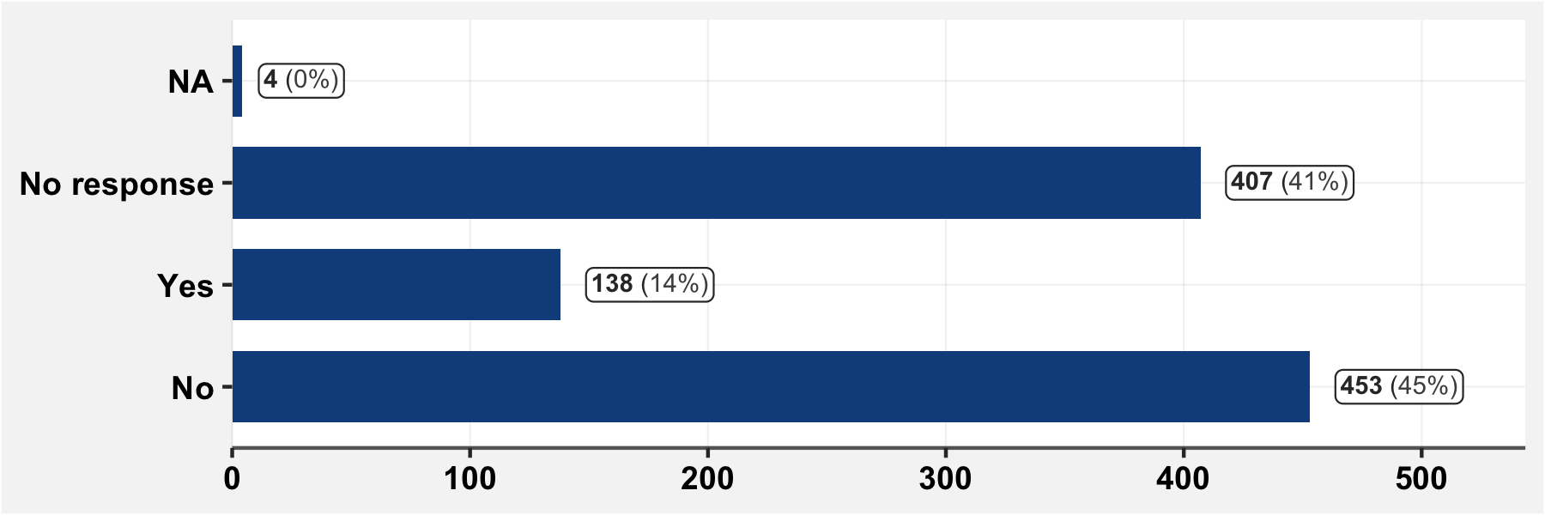

## 3.3 Who is the principal breadwinner in the household?

(Only answers from household representatives are shown.) 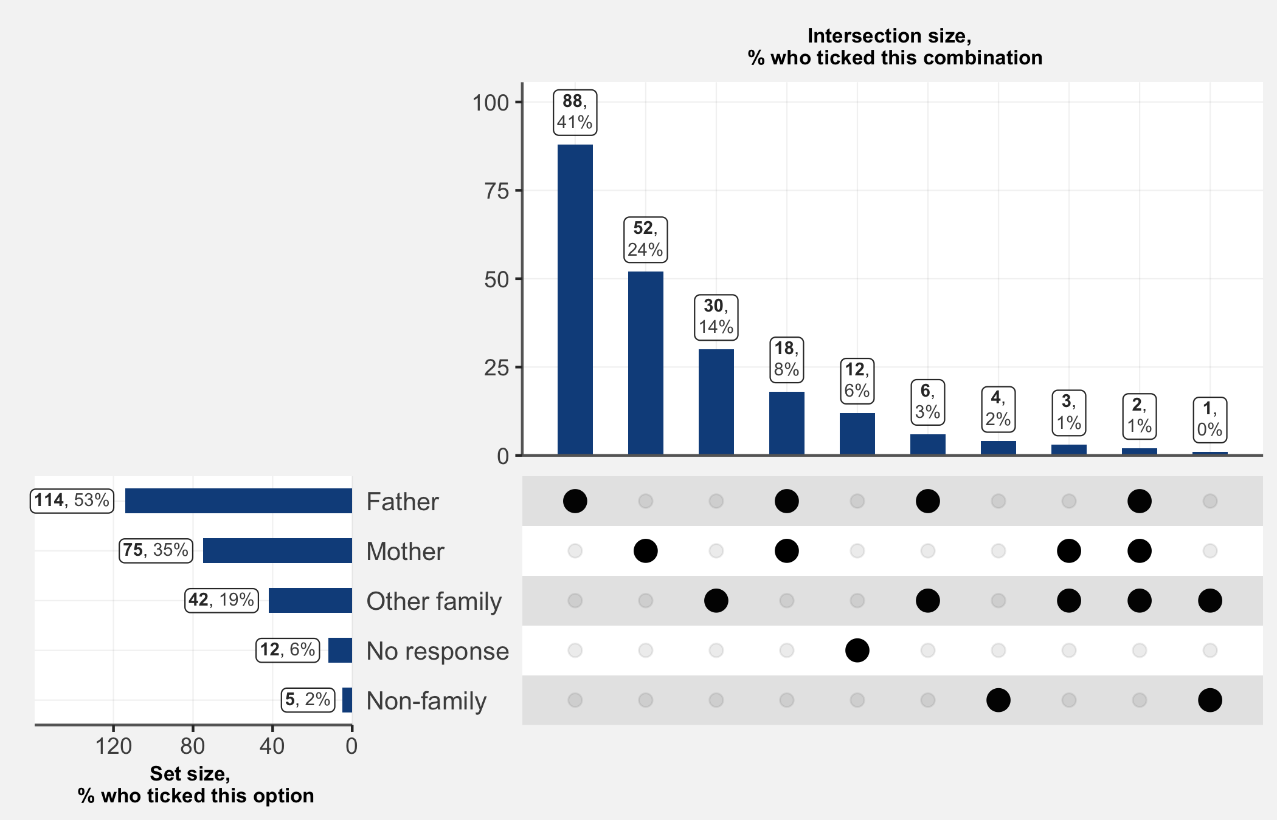

## 3.4 What are revenue sources of the family?

(Only answers from household representatives are shown.) 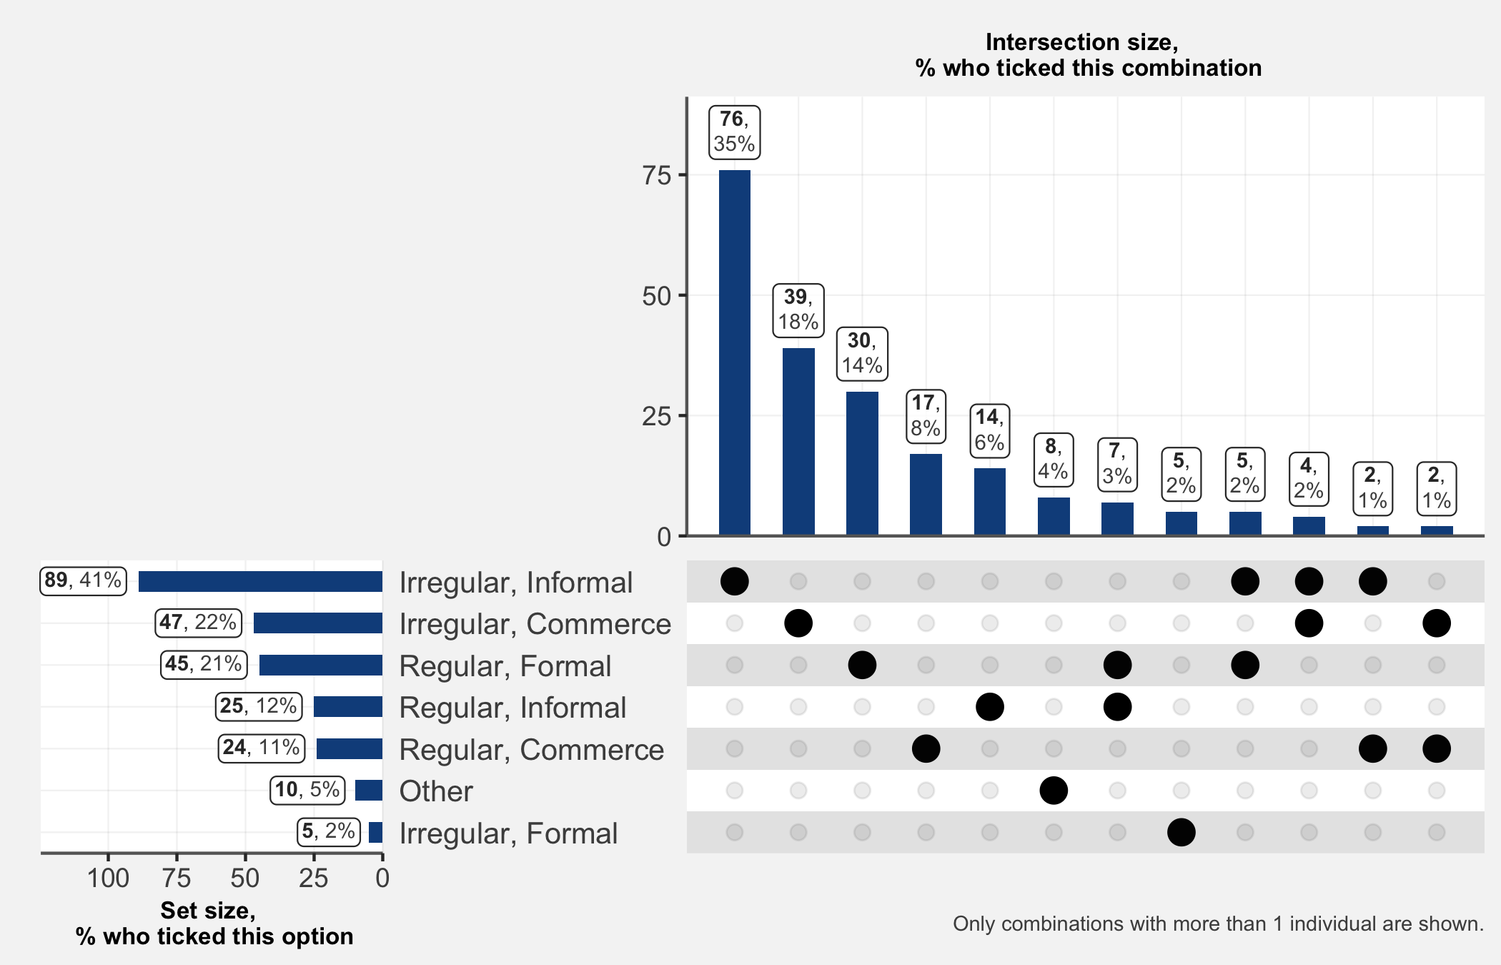

## 3.4.1 If you answered “Other” to the previous question, specify

|  |  |
| --- | --- |
| **Other income source** | **n** |
| Diaspora | 3 |
| Couturiere | 1 |
| Cultivatrice | 1 |
| Grande Soeur | 1 |
| Locataire | 1 |

## 3.5 Since March 1st, has the revenue of the household diminished?

(Only answers from household representatives are shown.) 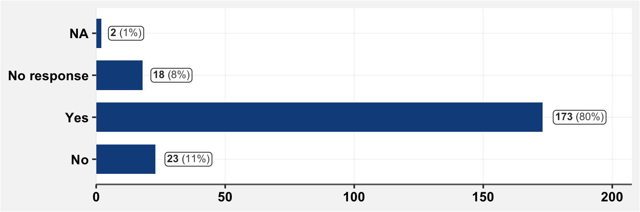

## 3.6 Has a household member lost their job or had their working hours reduced?

(Only answers from household representatives are shown.) 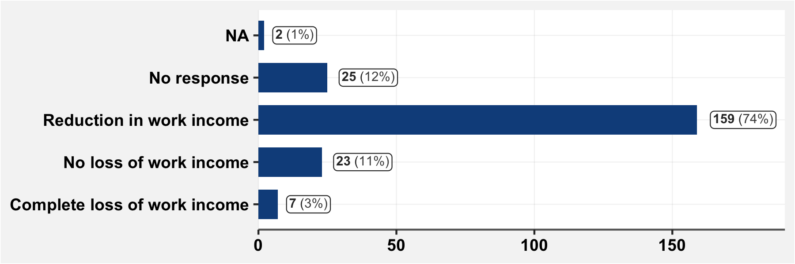

## 3.7 Has a household member tested positive for COVID-19?

(Only answers from household representatives are shown.) 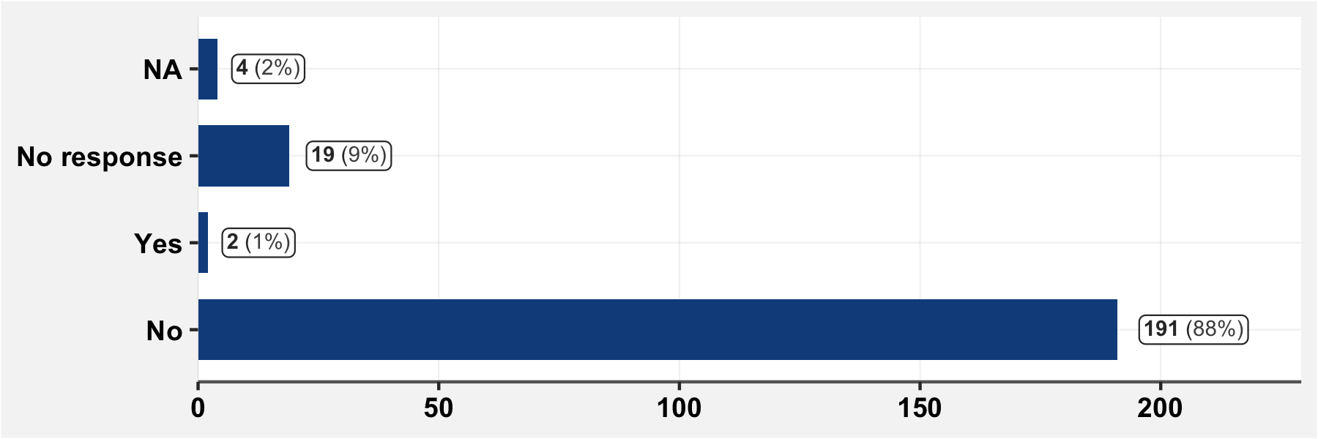

## 3.7.1 If a household member has tested positive for COVID-19, specify

|  |  |  |
| --- | --- | --- |
| **Date of Test** | **Age** | **Sex** |
| 2020-08-05 | 37 | F |
| 2020-05-15 | 51 | M |

# 4. Socio-administrative information about the surveyed individual

## 4.1 Sex

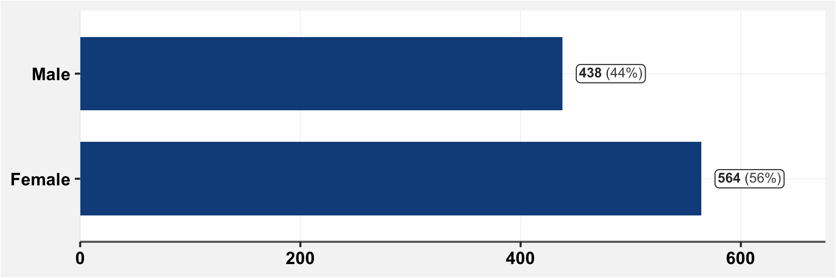

## 4.2 Age

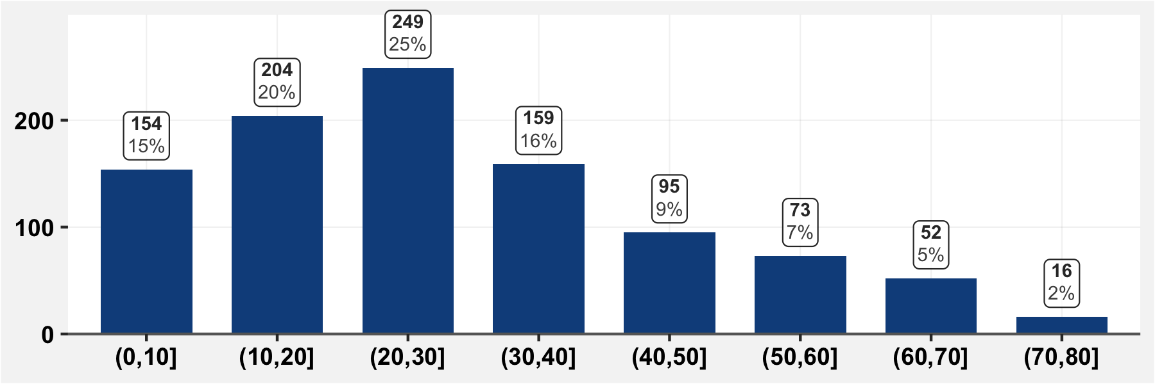

## 4.3 Date of birth

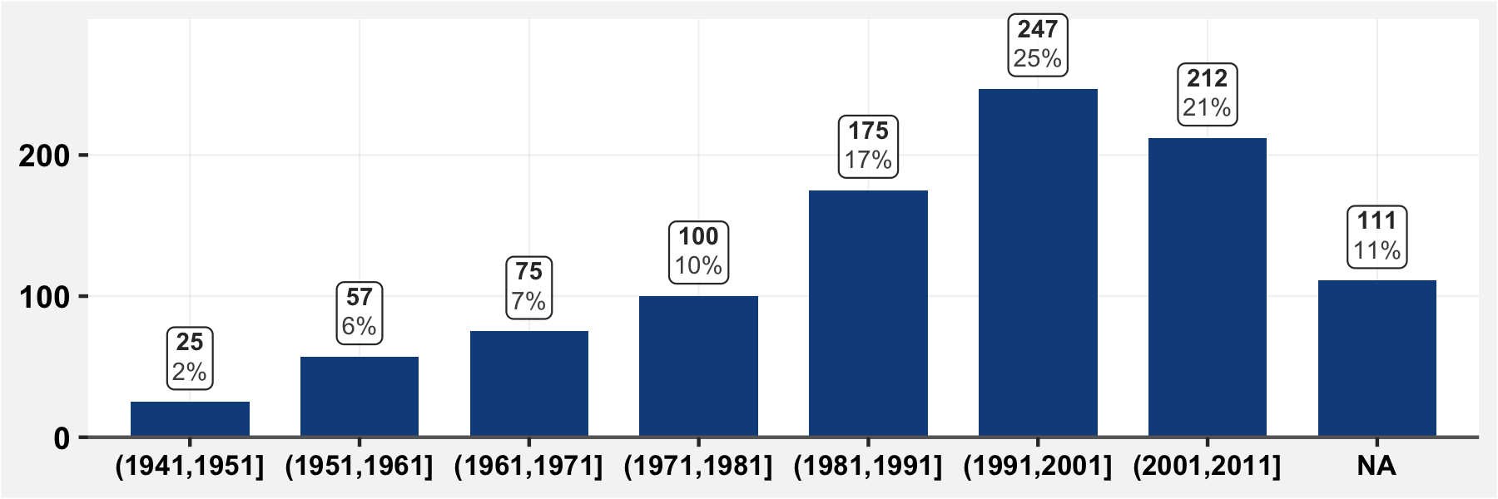

## 4.4 Education level

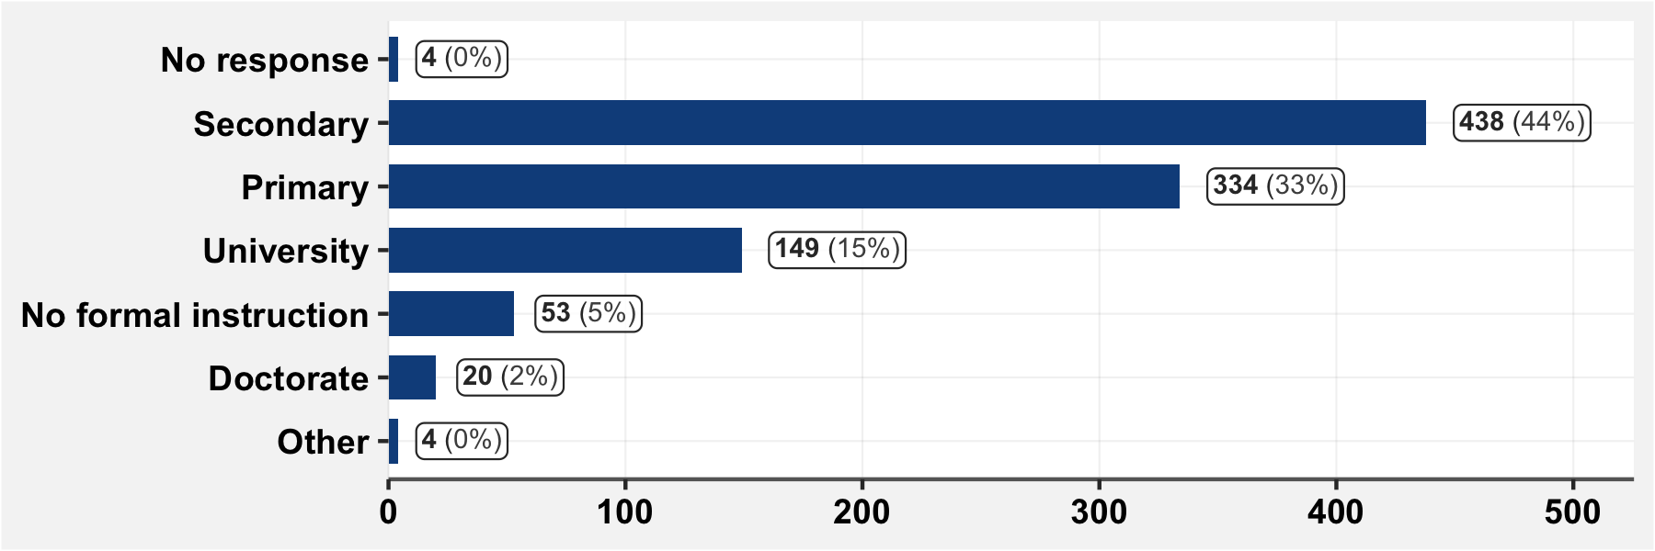

## 4.5 “Are you currently a…” (occupation)

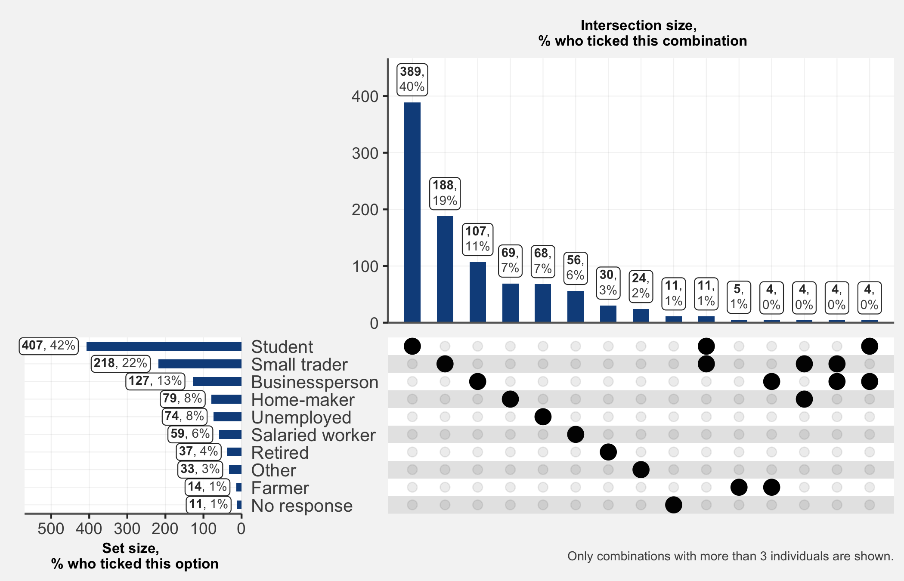

## 4.5.1 If you answered “Other” to the previous question, specify

|  |  |
| --- | --- |
| **Other occupation** | **n** |
| Eleve | 12 |
| Couturiere | 3 |
| Transporteur | 2 |
| Agent Communal | 1 |
| Consultant Expert Comptable | 1 |
| Elevage | 1 |
| Eleveur | 1 |
| Enseignant | 1 |
| Estheticienne | 1 |
| Etudiante | 1 |
| Infirmiere | 1 |
| Mecanicien | 1 |
| Rien | 1 |
| Taximen | 1 |

# 5. Symptoms suggestive of COVID-19

## 5.1 Since the 1st of March, have you had one or several of the following symptoms?

“These must be new symptoms without link to any chronic illness or already-known allergy.”

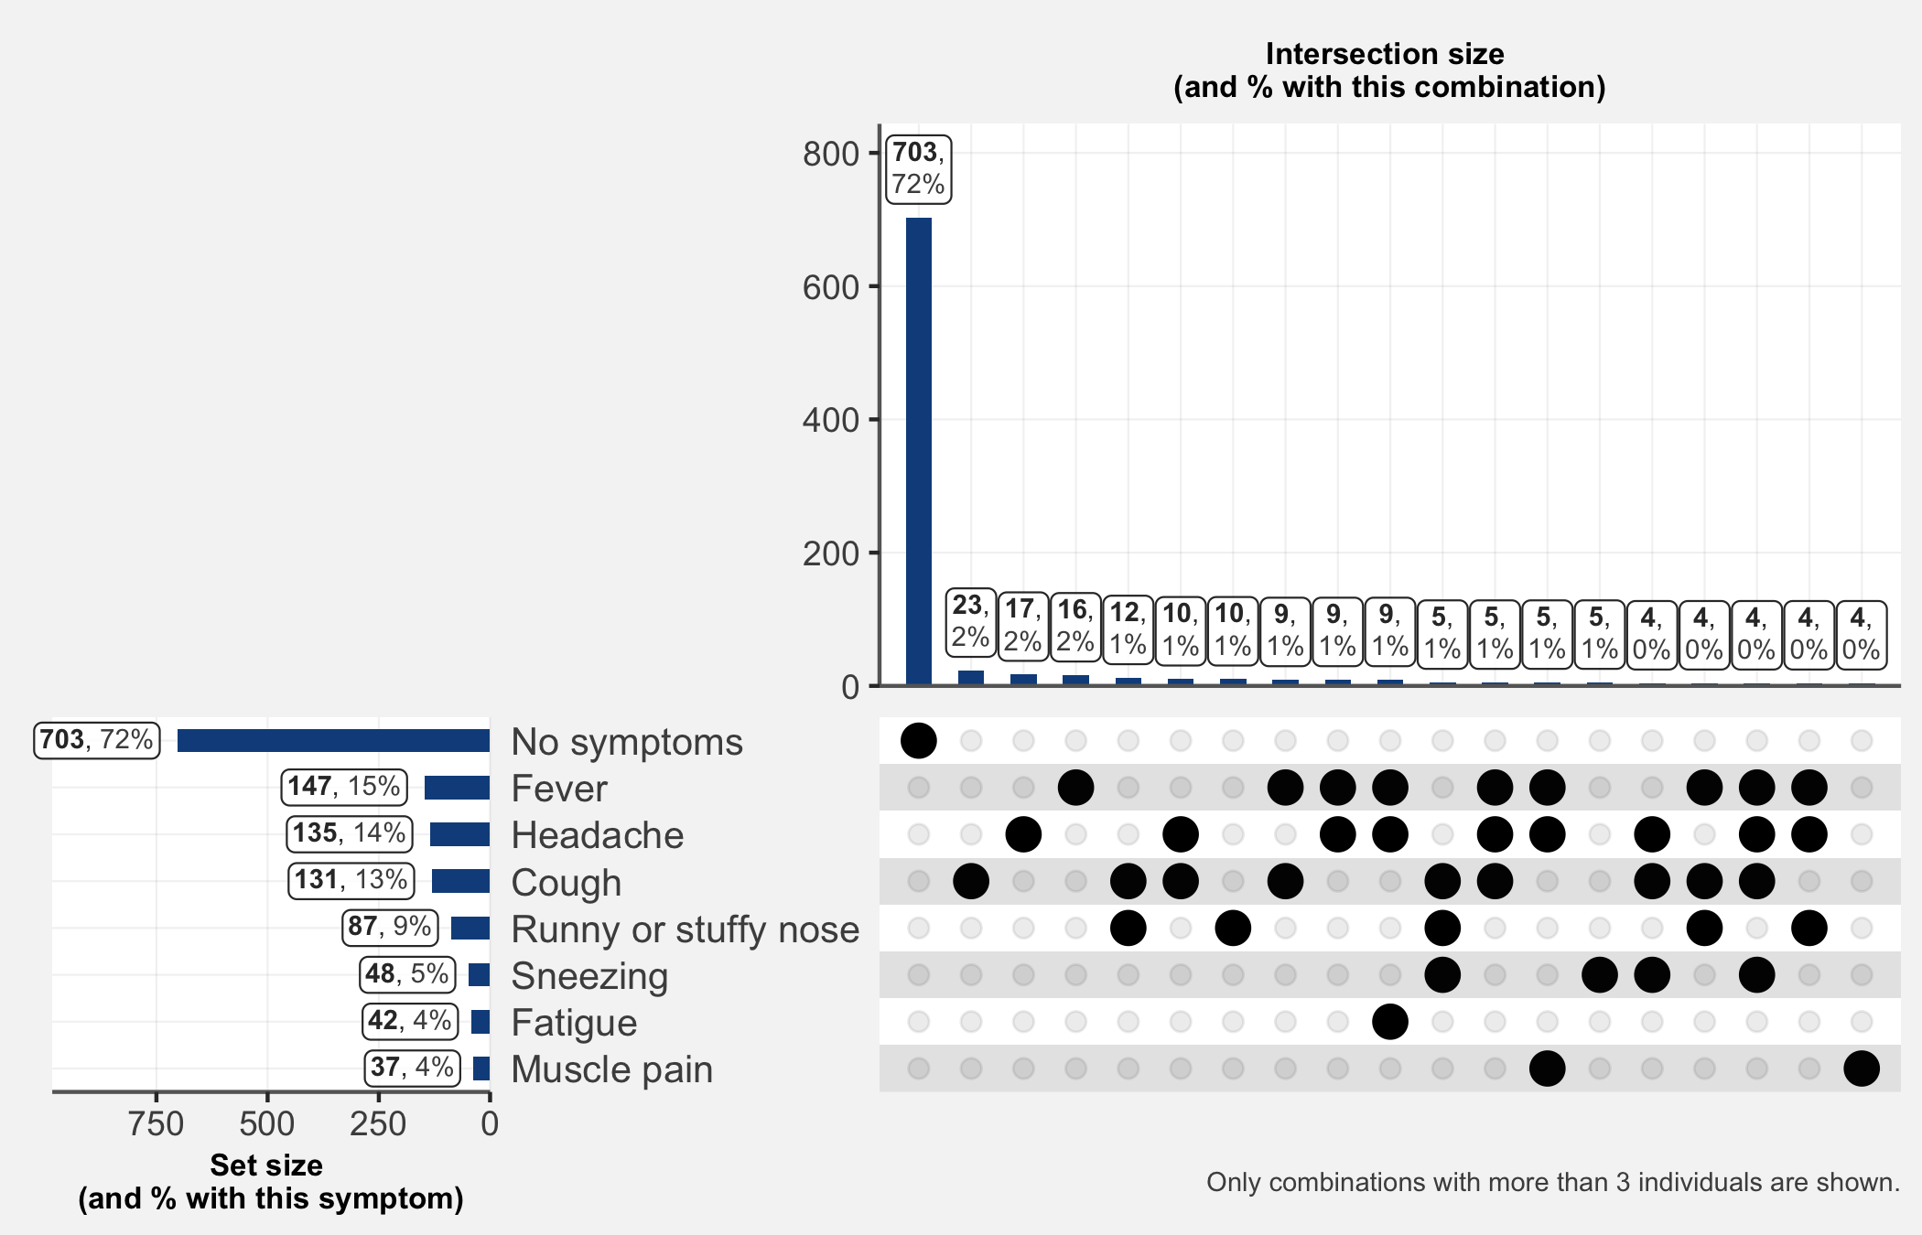

### Subset of those who have had symptoms

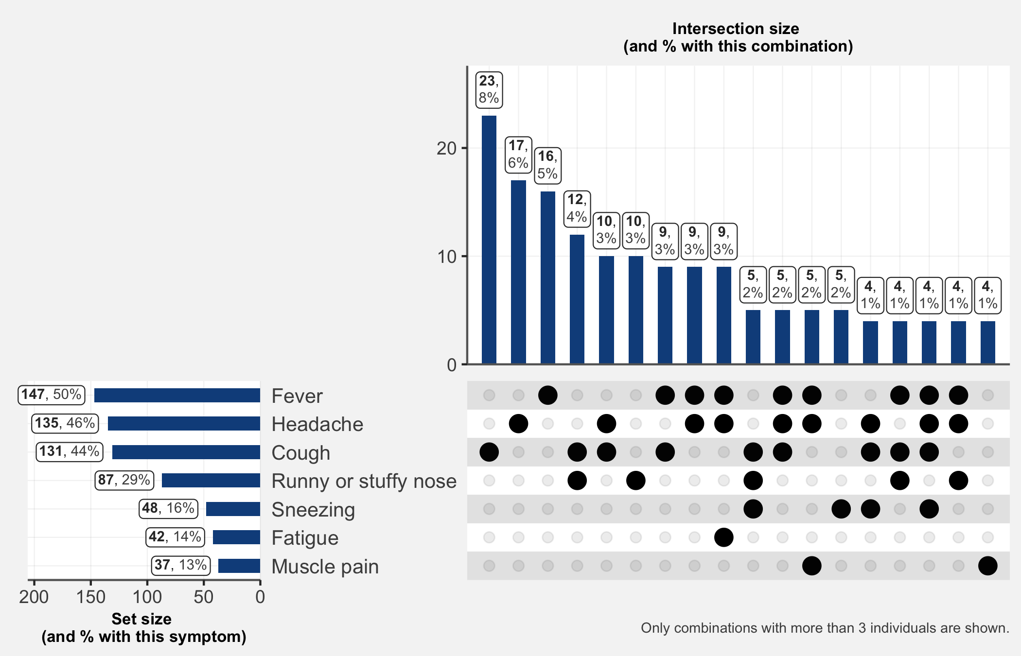

## 5.1.1 If you answered “other” to the previous question, specify

|  |  |
| --- | --- |
| **Additional Symptom** | **n** |
| constipation | 1 |
| Eruption cutanée | 1 |
| mal de ventre | 1 |
| mal de dos | 1 |

## 5.1.2 How severe have your symptoms been?

(Among those with symptoms) 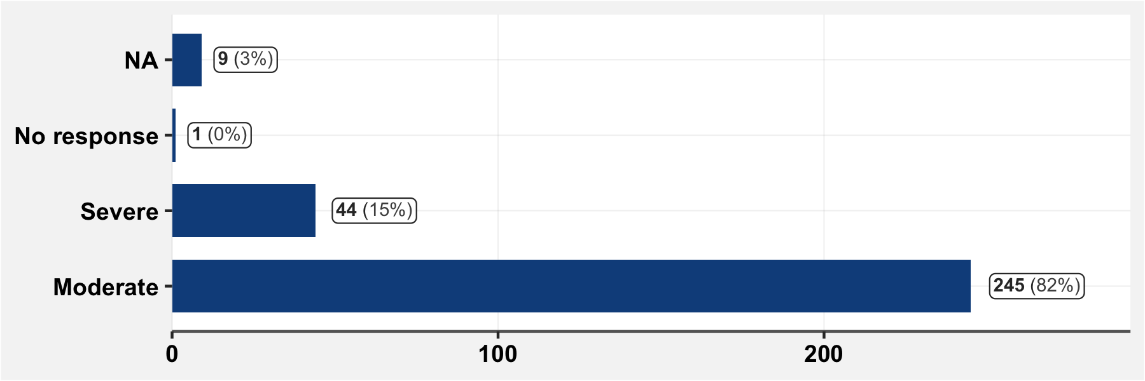

## 5.1.3 How many days were you bedridden?

(Among those with symptoms) 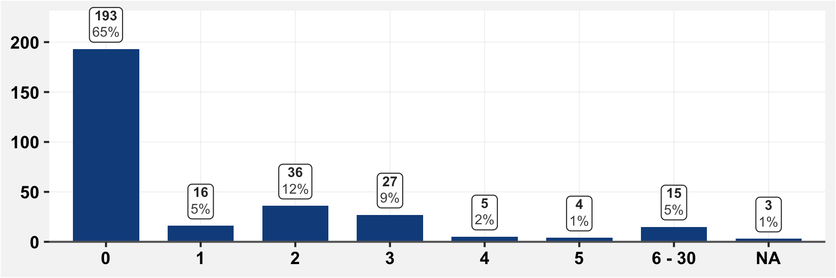

## 5.1.3 For how many days were you unable to go to work?

(Among those with symptoms) 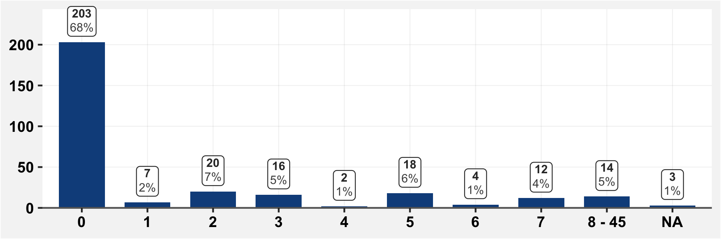

# 6 Treatment course for symptoms characteristic of COVID-19

## 6.1 Since March 1st, have you sought medical care for symptoms characteristic of COVID-19?

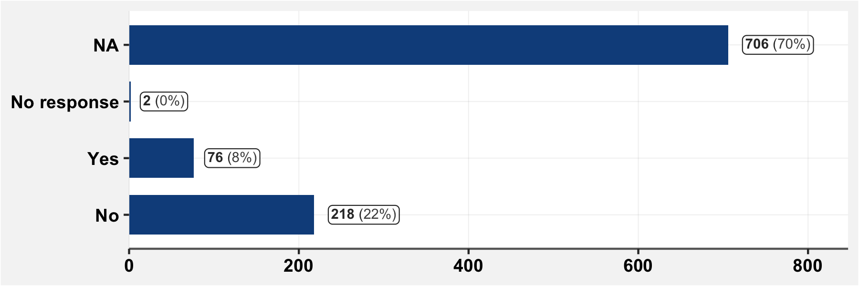

## 6.1.1 Who/Where did you consult for your symptoms?

(Among those who have consulted care.) 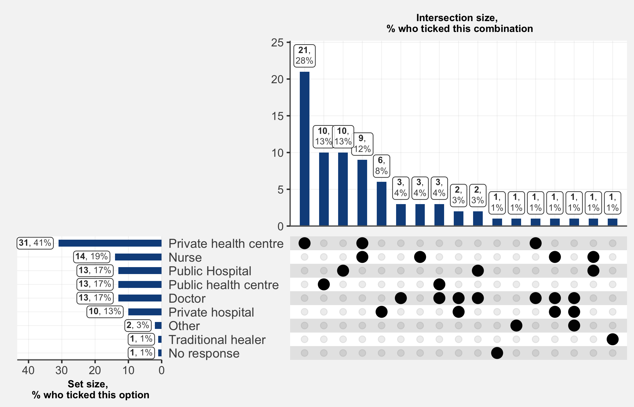

## 6.1.1.1 If you answered Other to the previous question, specify

|  |  |
| --- | --- |
| **Place of consultation** | **n** |
| Kinésithérapeute | 1 |
| Pharmacie | 1 |

## 6.2 Have you taken one or several medications for symptoms characteristic of COVID-19?

(Among those who have consulted care.) 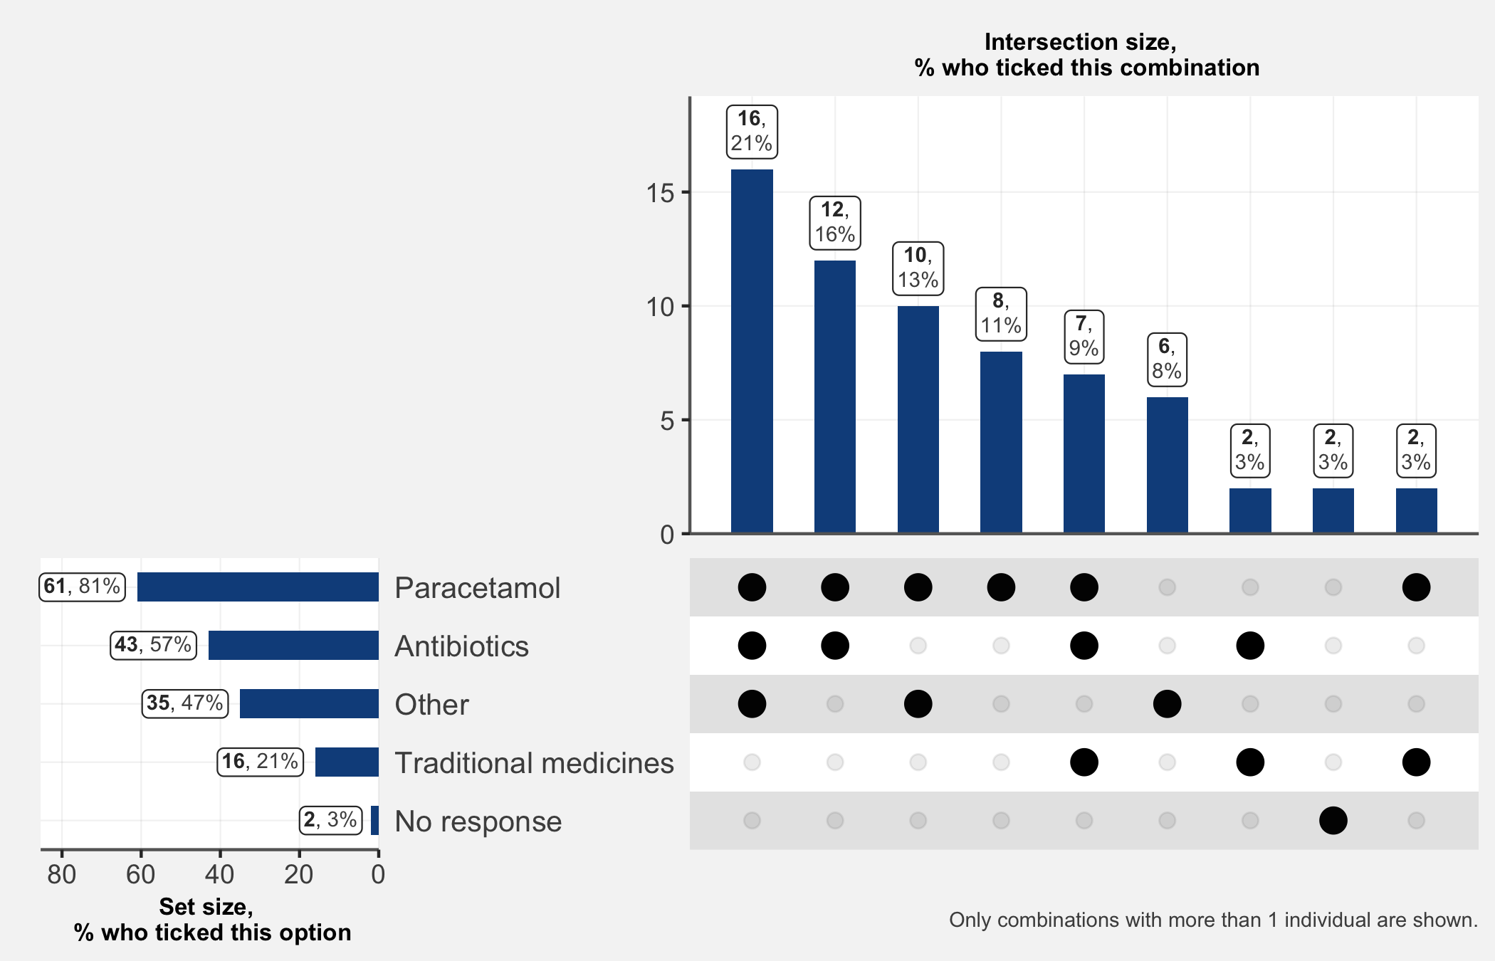

### 6.2.1 Other medications

(We could clean this up later)

|  |  |  |  |
| --- | --- | --- | --- |
| **Drug** | **n** | **Drug** | **n** |
| Anti Paludeen | 19 | Cold Cap | 1 |
| Mixagrip | 5 | Combiart | 1 |
| Antipaludique | 4 | Correctol | 1 |
| Anti Paludique | 3 | Décongestionnant Nasal | 1 |
| Anti Paludisme | 3 | Dexa | 1 |
| Litacold | 3 | Duo Cotexin | 1 |
| Oublie | 3 | Exomuc | 1 |
| Anti Paludein | 2 | Glucose | 1 |
| Arthemether | 2 | Hpv | 1 |
| Vermifuge | 2 | Lunettes Médicales | 1 |
| Allergenes | 1 | Lutacold | 1 |
| Analgin | 1 | Malacur | 1 |
| Andipaludeen | 1 | Migretil | 1 |
| Anti Grippal | 1 | Perfusion ... Ne Connais Pas Le Traitement | 1 |
| Antitussifs | 1 | Peridys | 1 |
| Artefan Comprimé | 1 | Primant | 1 |
| Artesunate Injectable | 1 | Quinine Paracétamol Lutacold Amoxixilline | 1 |
| Arthemeter | 1 | Sterimar | 1 |
| Arthemeter Comprimé | 1 | Ventoline. Aspirine. Mucoxine. Amlibon 30. Omeprazole. | 1 |
| Bactoxin | 1 | Vit C | 1 |
| Bonbons Tom_tom | 1 |  |  |

## 6.4 Have you been hospitalized since March 1st?

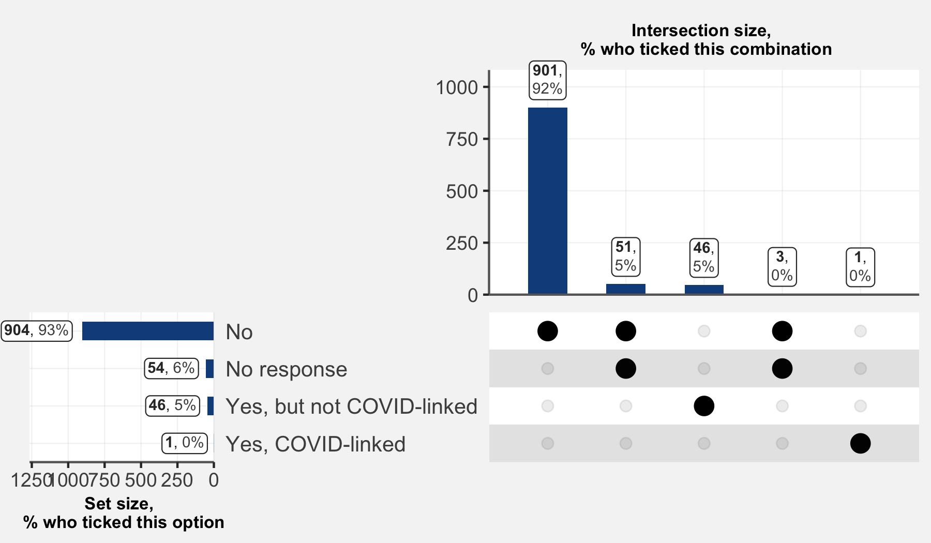

## 6.5 If you have taken steps to access care regarding suspected or confirmed COVID-19, did you pay?

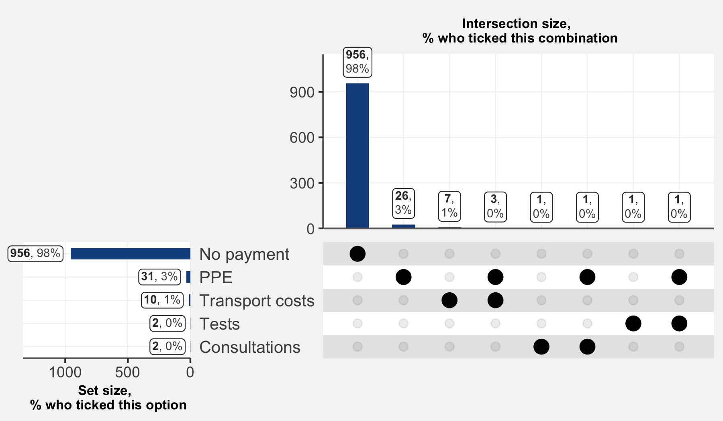

## 6.6 Have you participated in a COVID 19 Study?

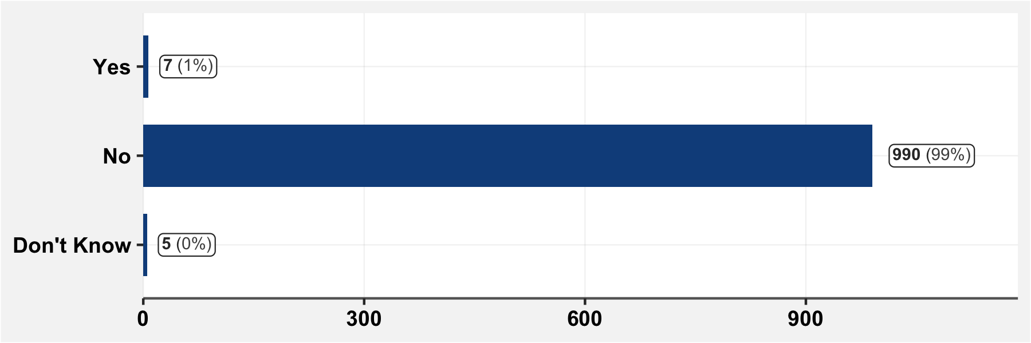

# 7 Sequelae following COVID-19-like symptoms

## 7.1 Have you had health problems which have persisted after having COVID-like symptoms?

(Subsetted to those who showed COVID-like symptoms)

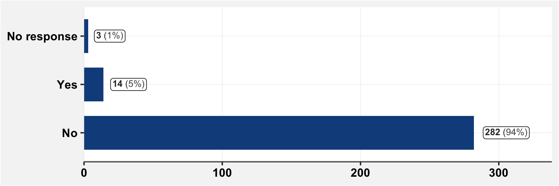

## 7.1.1 If yes to the prior question, specify

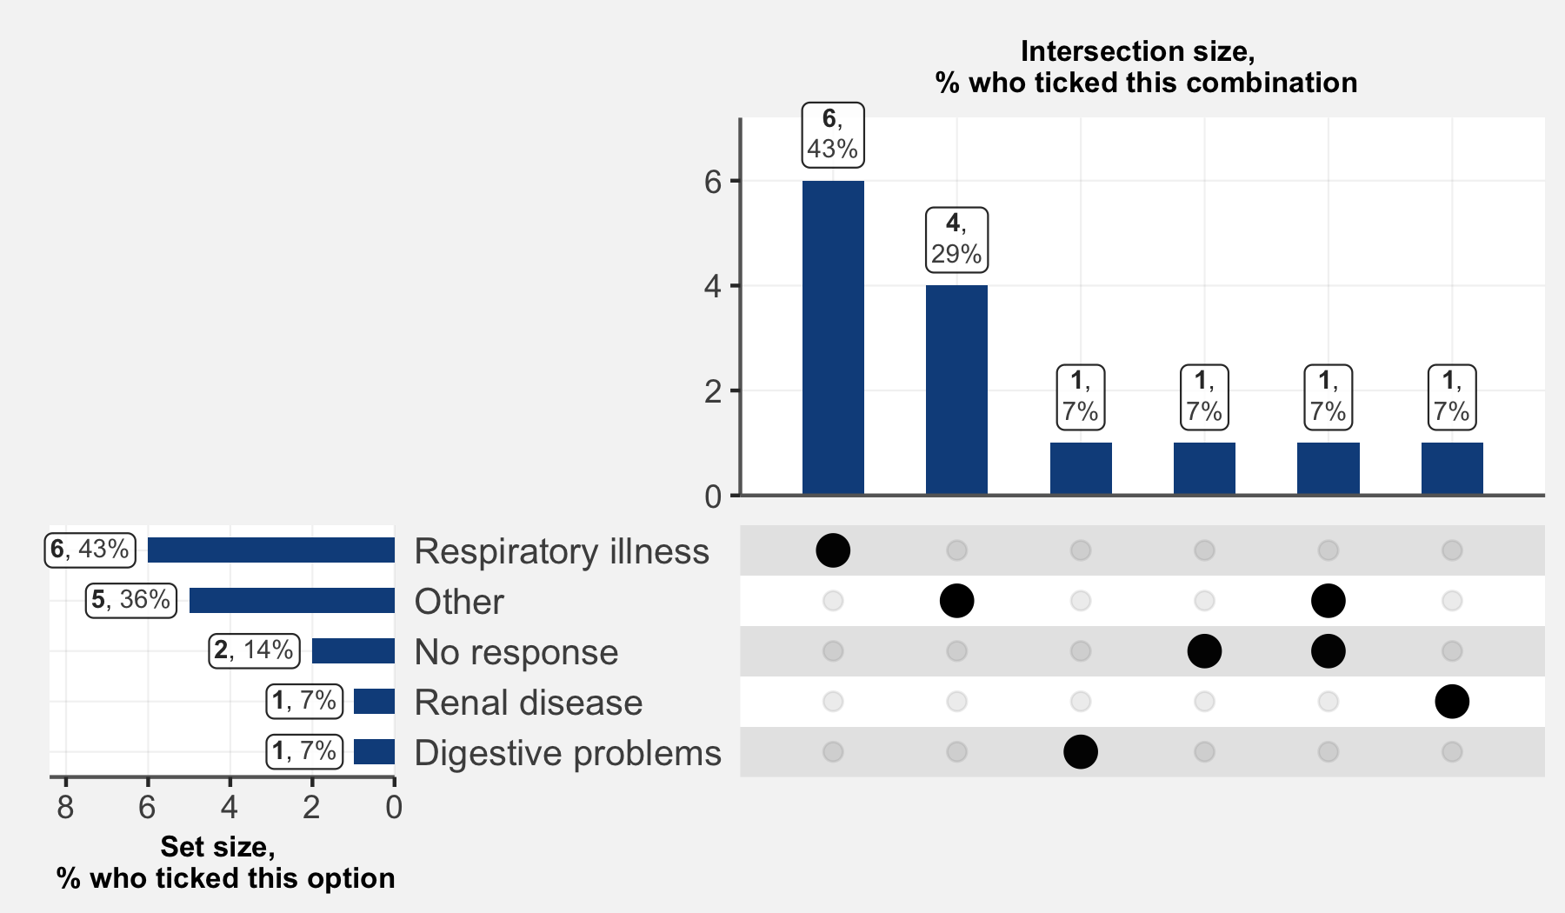

# 8 COVID-19 tests carried out before the visit

## 8.1 Have you carried out any screening test for COVID-19?

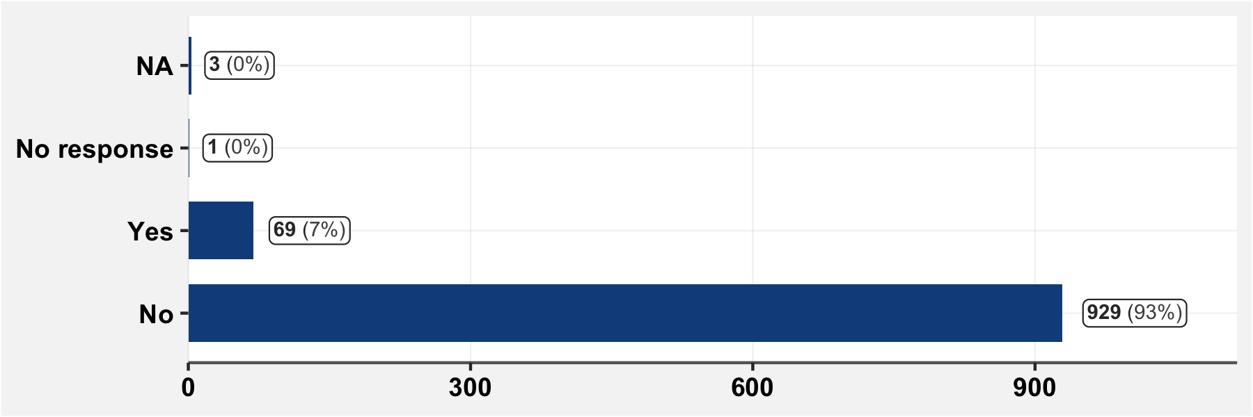

## 8.1.1 If you have previously had a COVID test, specify

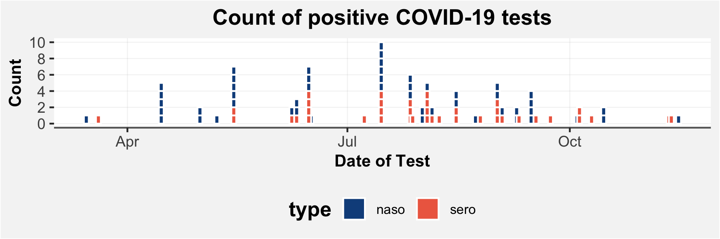

No negative tests were reported, and 7 tests were reported which had unknown results.

## 8.1.2 If you have previously had a COVID test, for what reason was the test done?

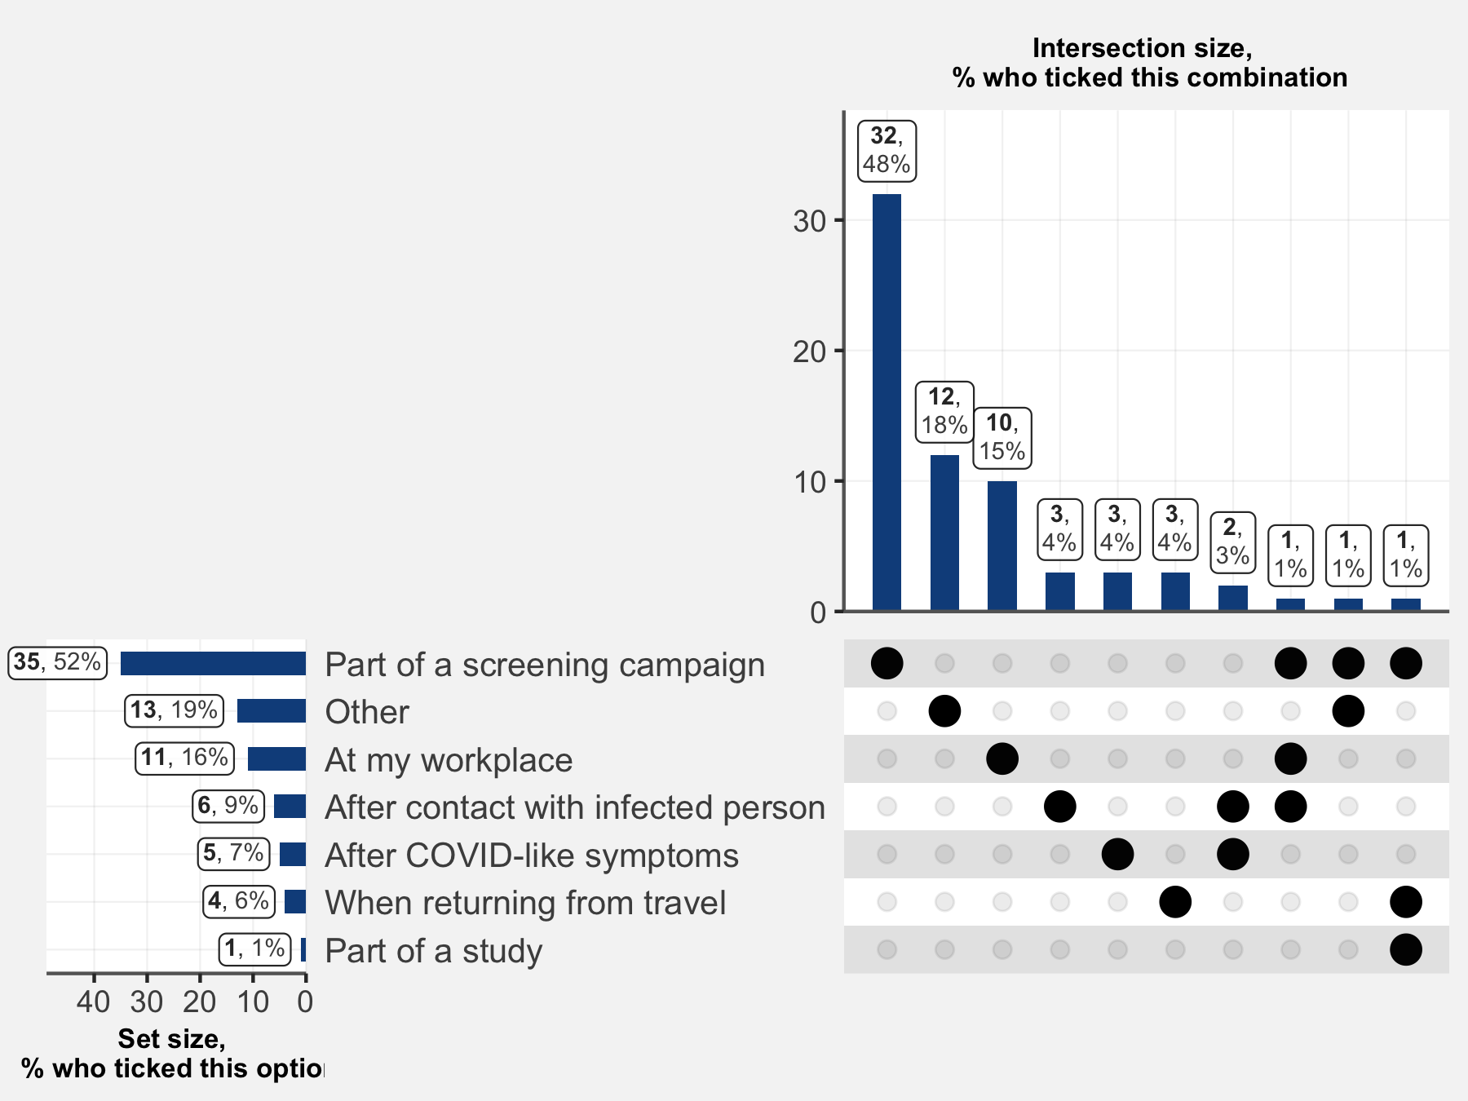

## 8.1.1.1 If you responded “Other” to the previous question, specify

|  |  |
| --- | --- |
| **Reasons for testing** | **n** |
| volontaire | 2 |
| Voyage | 2 |
| Dans le cadre de suspicion d’un membre de la famille | 1 |
| Dossier de voyage | 1 |
| Exigé par l'administration à l'école | 1 |
| Hasard | 1 |
| pour avoir accès à un service public | 1 |
| Pour un travail | 1 |
| rentrée scolaire des enfants | 1 |
| Test volontaire | 1 |
| Tests de routine | 1 |